Session-6

Imagine Now the implementation is successful and all programs are running fine. Eventually you are in S4HANA successfully. 🡪 we are now in HANA DB

In what basis is performance is good in SAP HANA

SAP has given the performance guidelines.

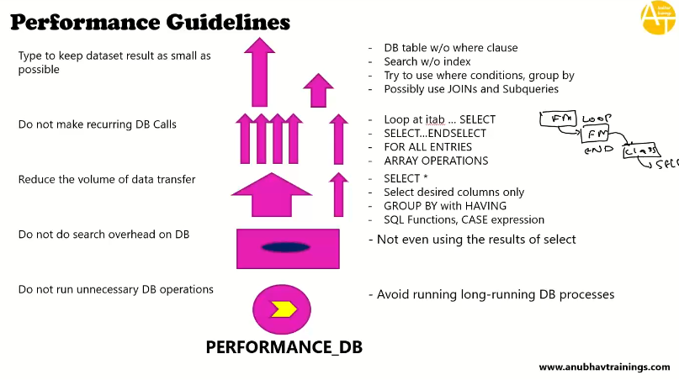

**Performance check variant – PERFORMANCE_DB**

**12:02**

**Tables:**

Snwd_so_inv_head

Snwd_so_inv_items

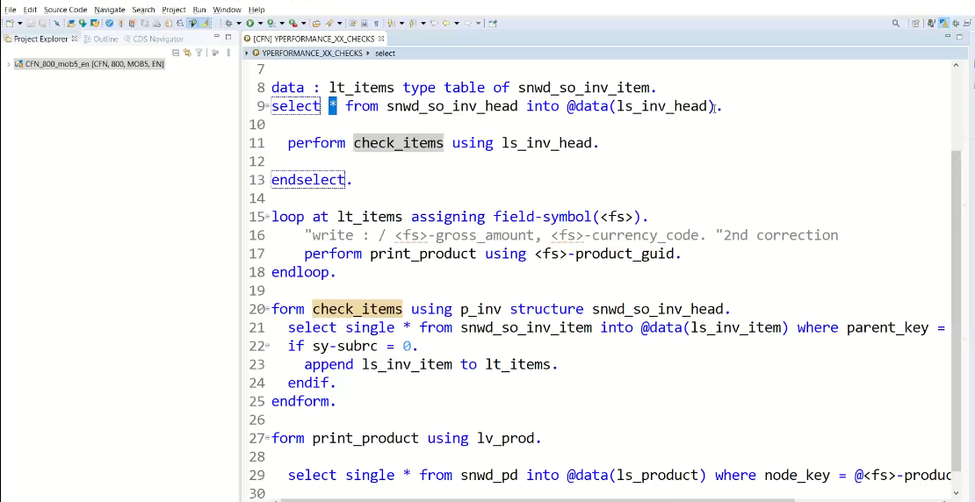

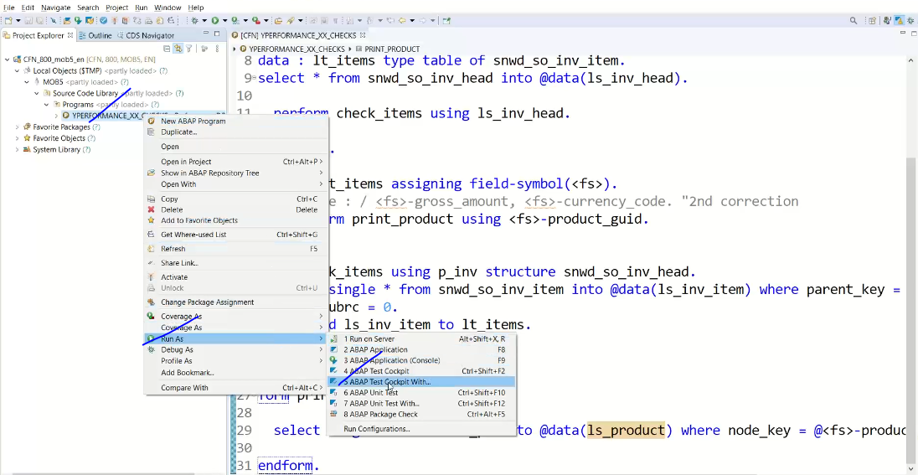

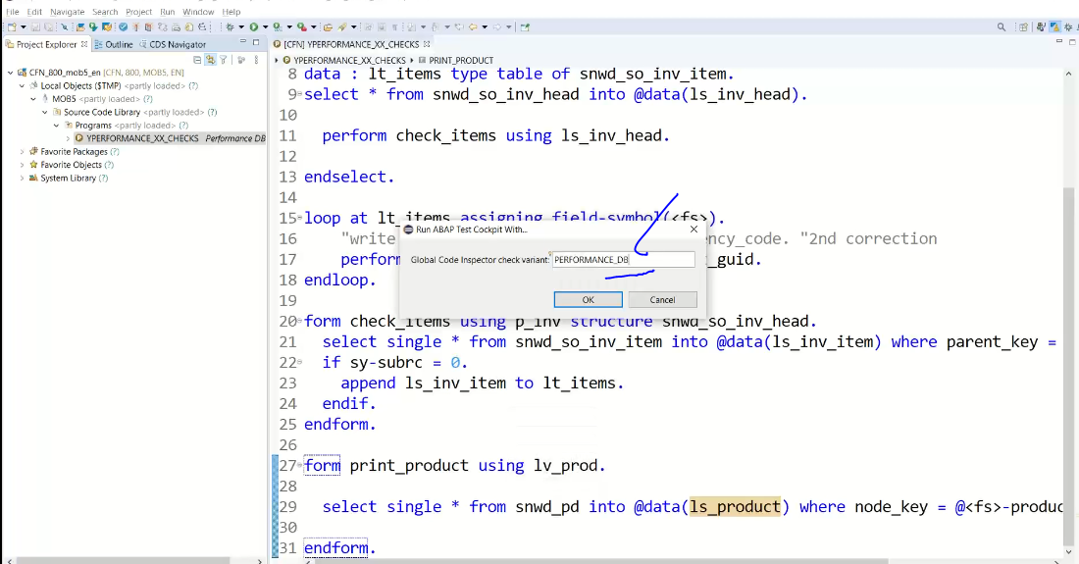

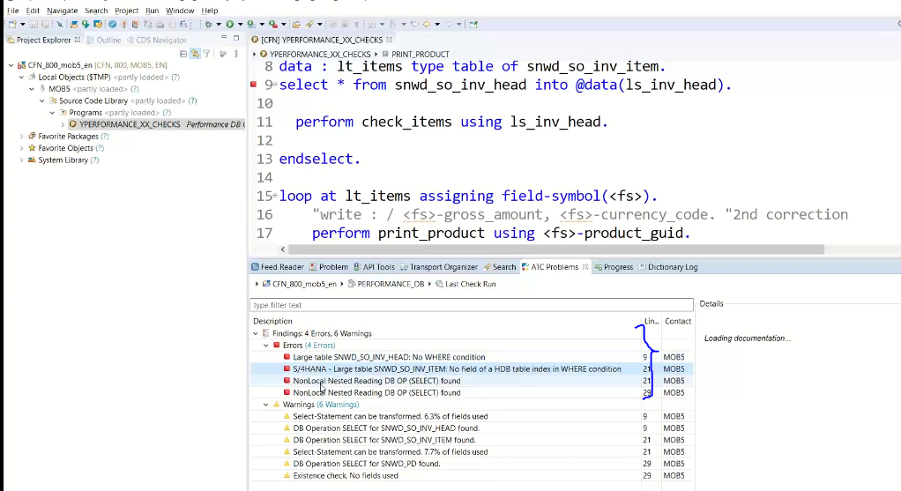

These all are static checks

What about runtime performance?

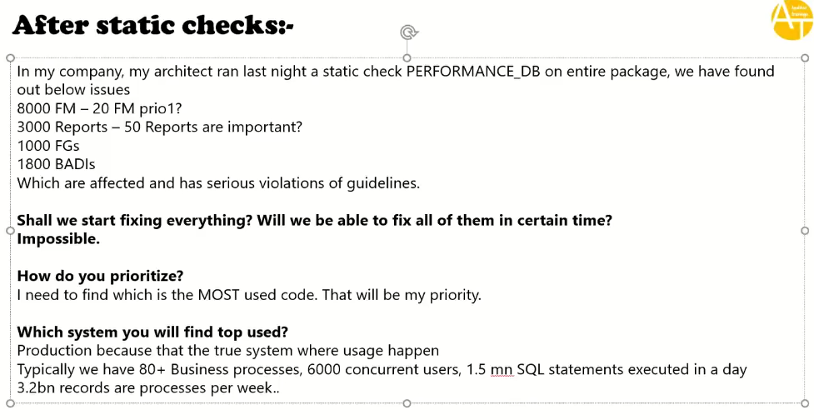

**23:00**

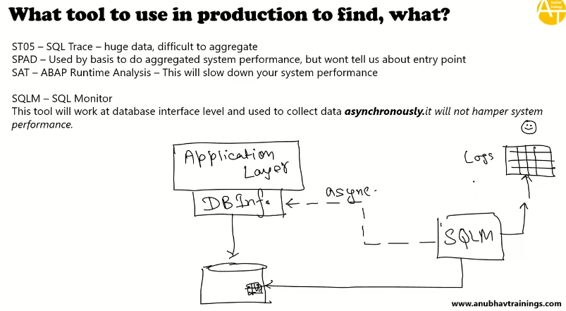

**SQL Trace:ST05:**

* It gives huge amount of data which is difficult to aggregate (Query was rn 10000 times there are 10000 records which will come in SQL trace ).
* It is telling that number of times SQL statement run.

SPAD:

* used by basis to do aggregated system performance but won’t tell about entry point(Query explanation will give but which program it is giving that issues this tool not provide.

SAT: ABAP runtime analysis

* this will slow down your system performances, business will not accept in production to run

SQLM:

* SQL Monitor tool
* SAP has introduced the Net weaver 7.2 SP02.
* Asynchronously work
* Performance wise it is good.

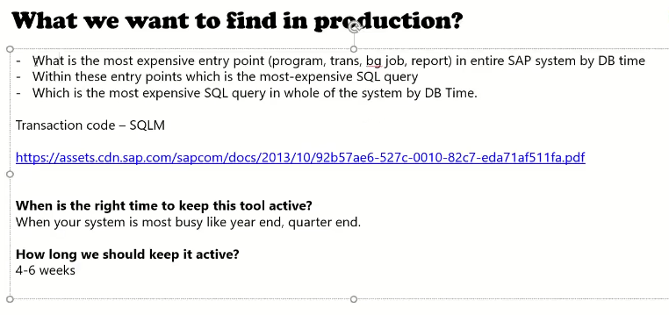

To Execute the SQLM we need to activate this in the system.

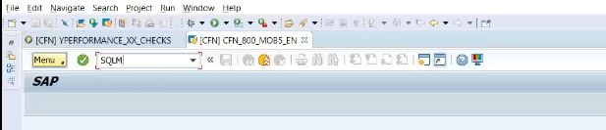

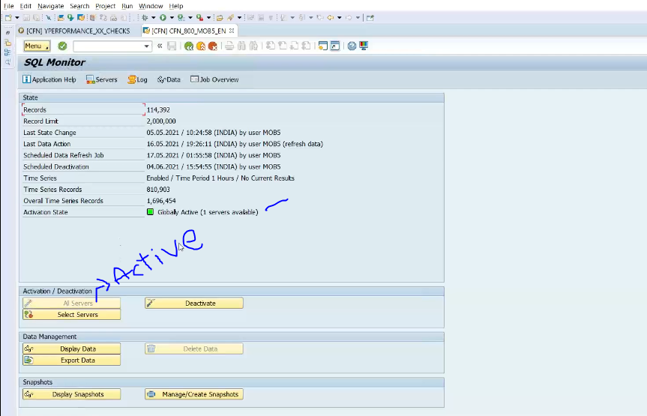

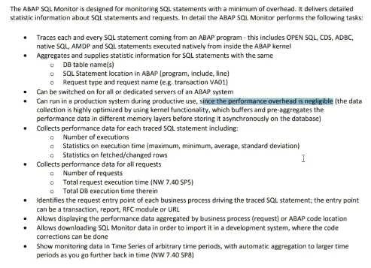

* Click on Display data in SQLM screen shot( because we have ran couple of programs ).

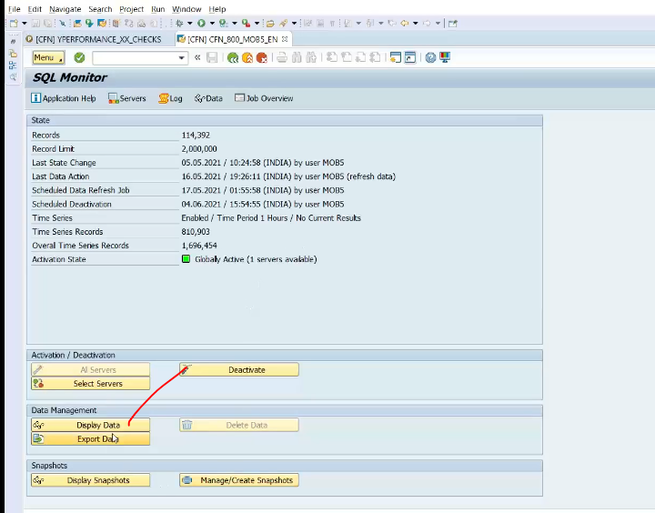

By Request 🡪 entry point

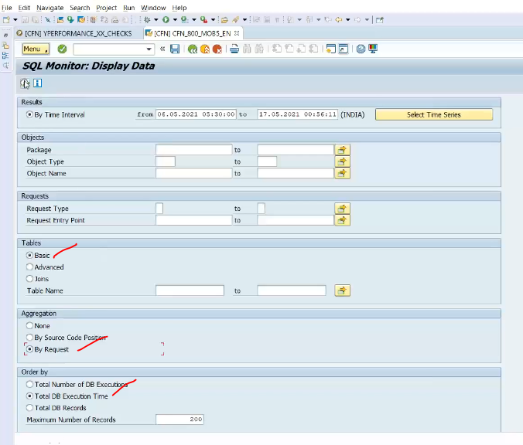

F8

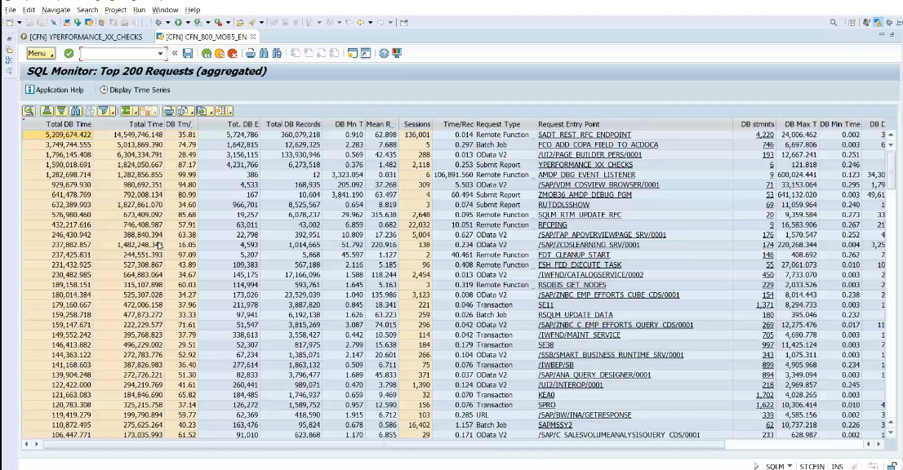

First 3 are standard programs .. don’t care this.

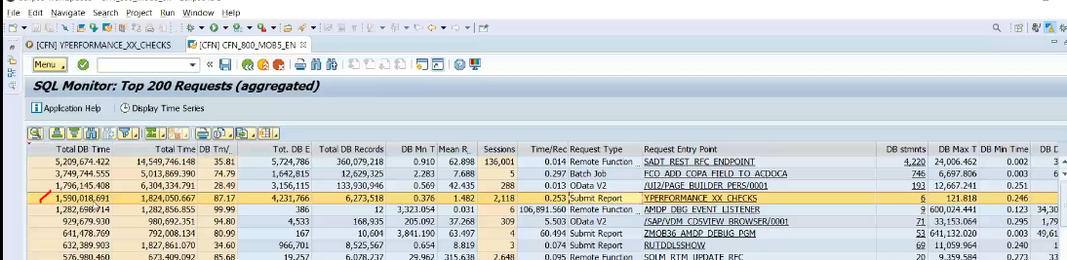

DB time – in % giving 87% spent on DB

Here found out most expensive database operation

Mean records – fetching records

DB execution: number of execution.

Dbl click on selected record.

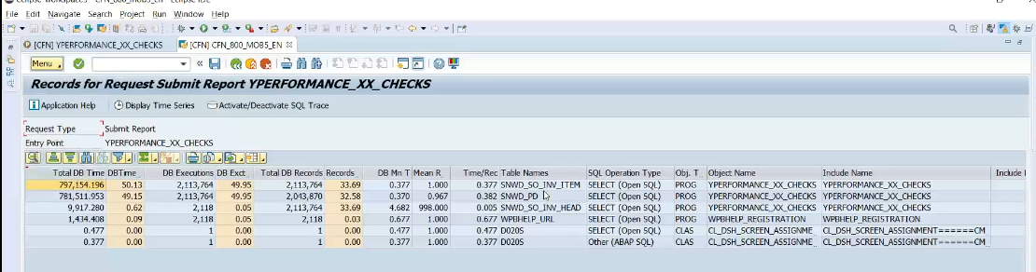

First two records are time taking records.(With in these entry points which is the most-expensive SQL query)

Dbl click first one take me to the programs

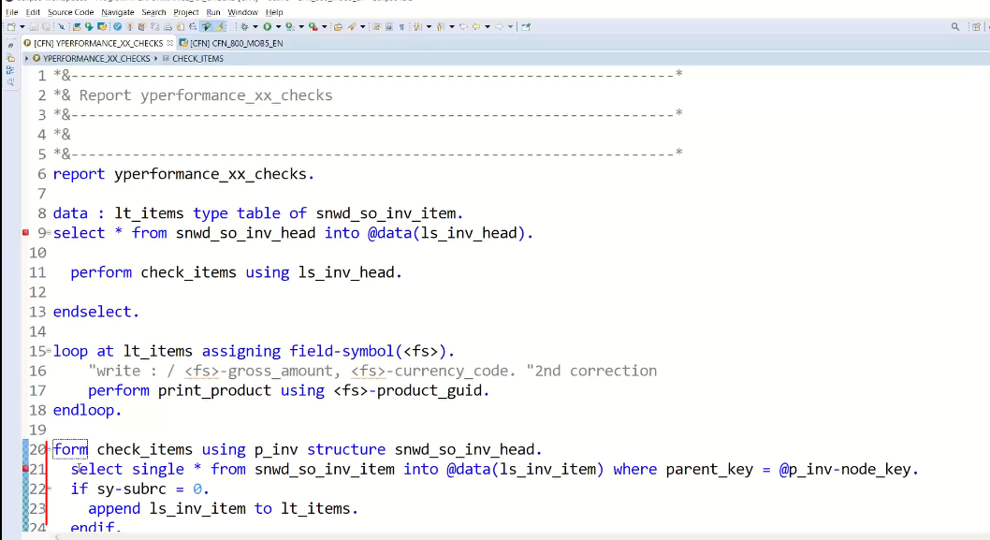

This is the nested select statement hitting a big database table.

Which is the most expensive SQL query in whole of the system by DB time?

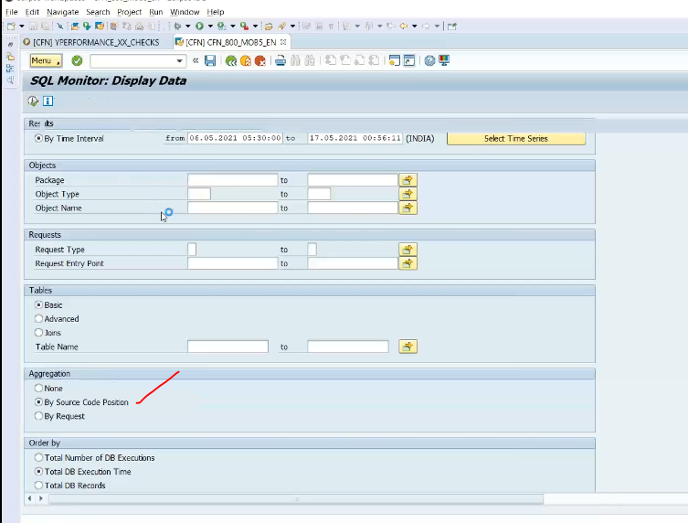

F8

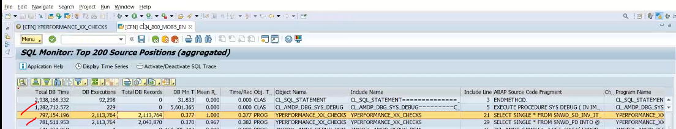

Take these dump

* RUN SQVM tcode

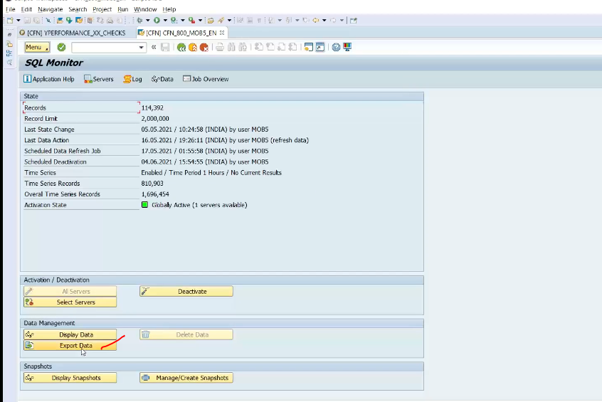

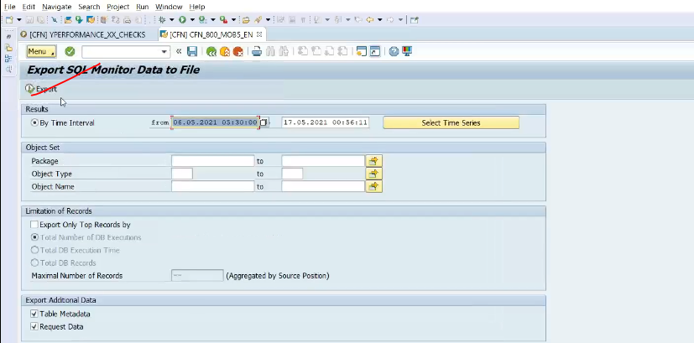

F8

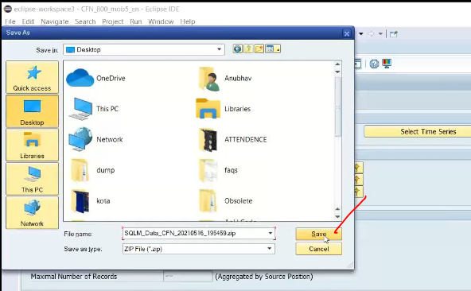

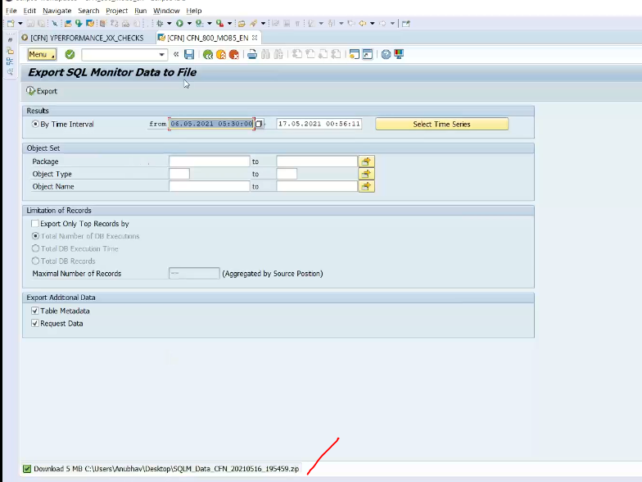

Download has completed

SWLT( SQL worklist monitor ):

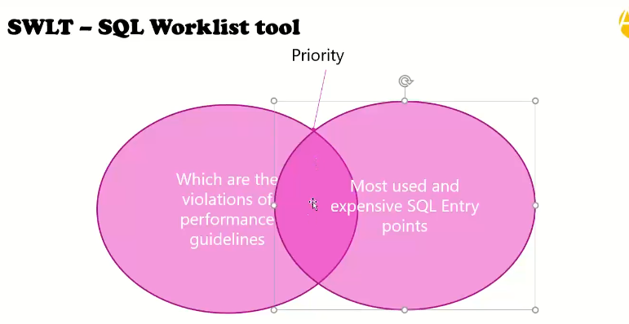

* Used for static checks and sql monitor(SQLM)
* Take the dump from SQLM( download this dump of data ) , once complete
* Execute SWLT tool

Static checks

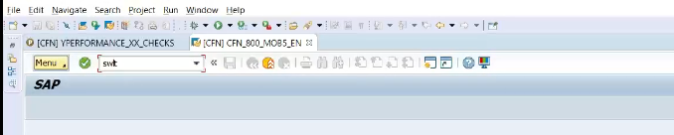

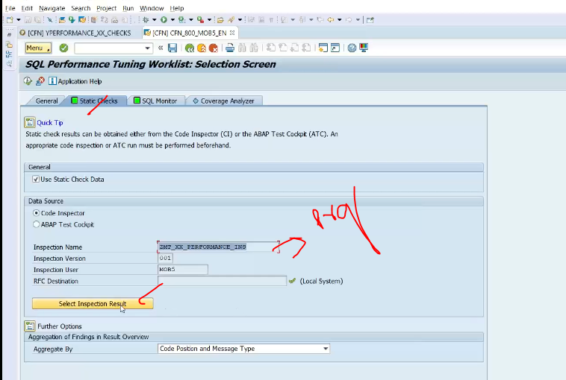

SQLM:

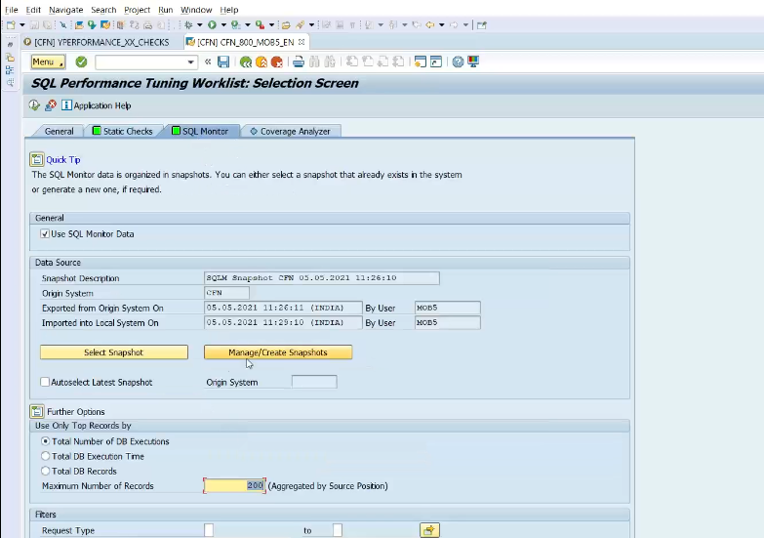

Click on manage snap shots

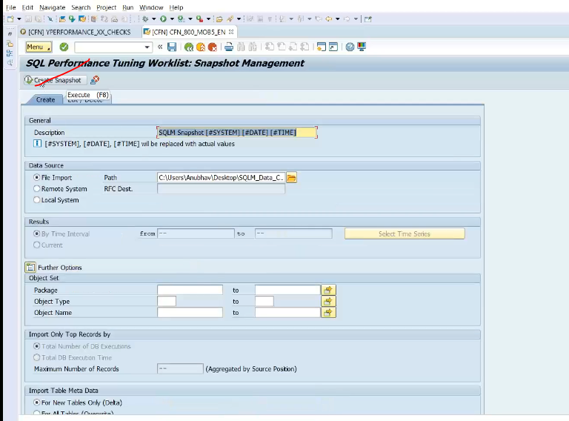

Select the zip file downloaded from SQLM.

Take the path in File import.

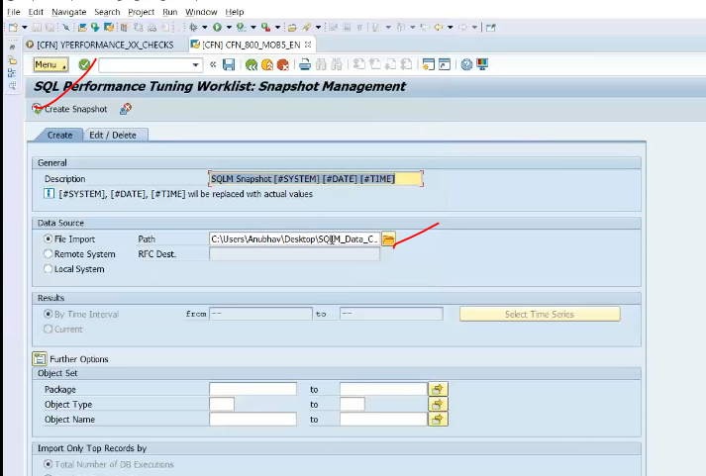

F8

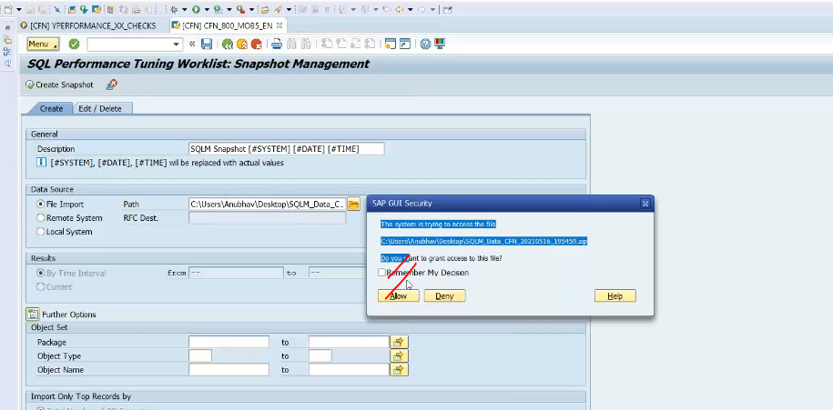

Uploading the zip file which I got from production system into my development system.

Now system will do the both the inter section of static checks and SQLM and parallel it is come.

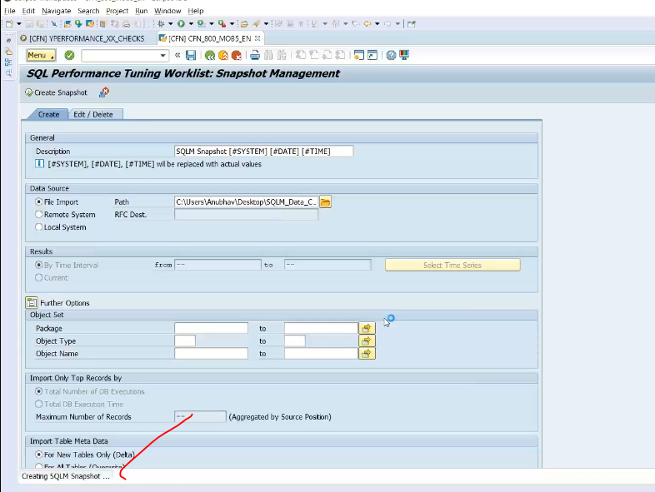

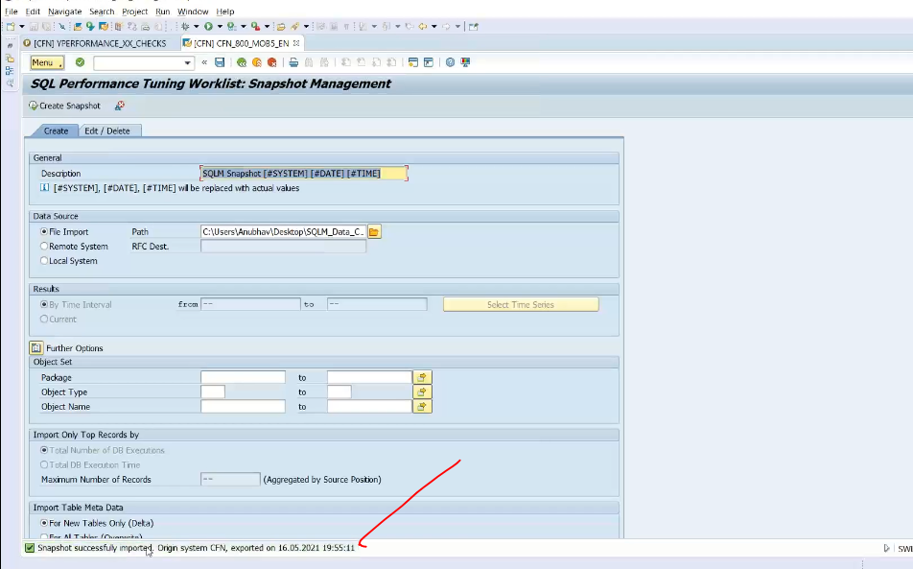

Now go to the SWLT initial screen for SQL Monitor

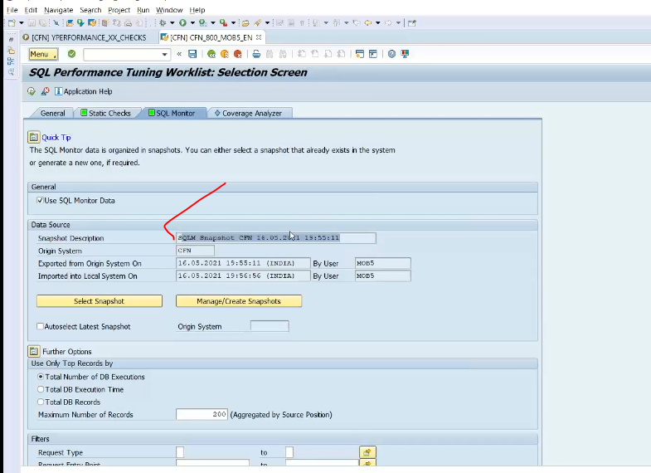

Snap shot has selected

Press F8

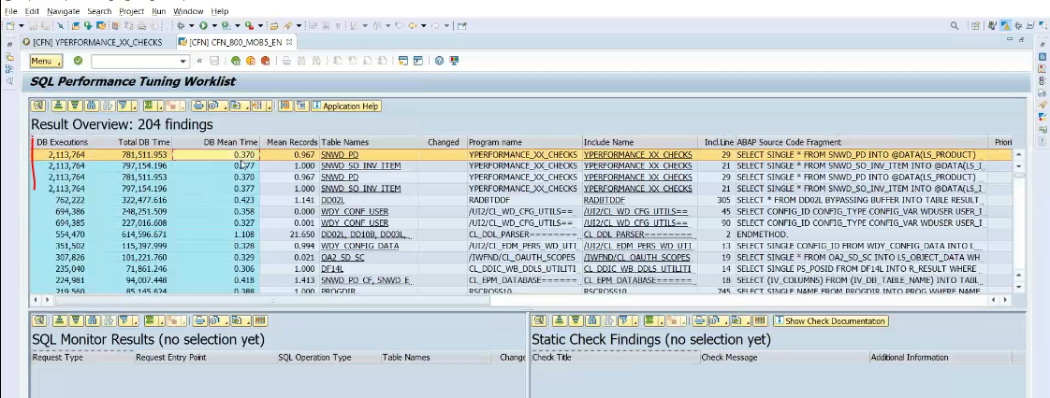

Dbl click on findings

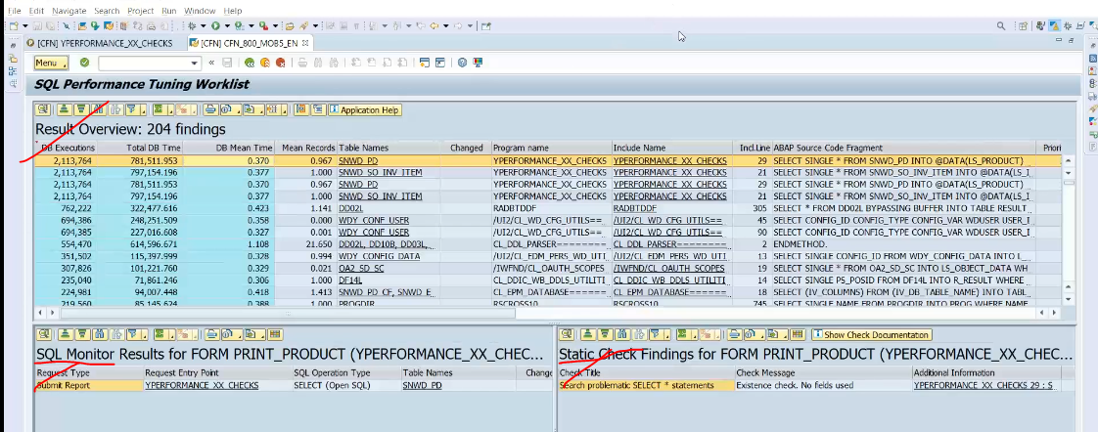

Now developer will do the code based on performance checks

51:00

**Data Model- EPM- Enterprise Procurement Model:**

* Very much related to real time
* What is EPM data model:

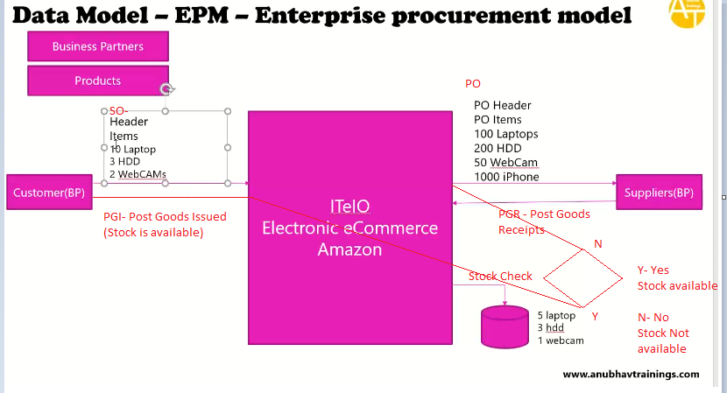

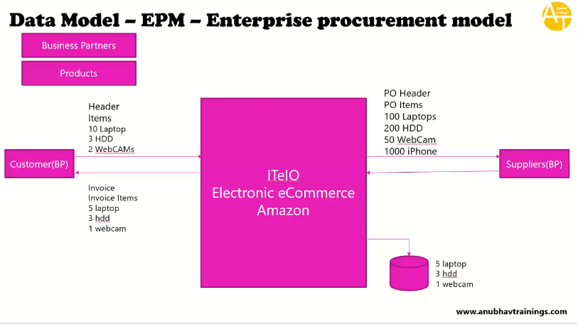

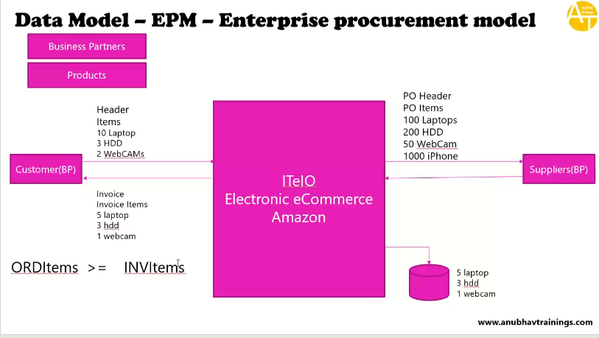

**Tables:**

* All the tables starts with SNWD*

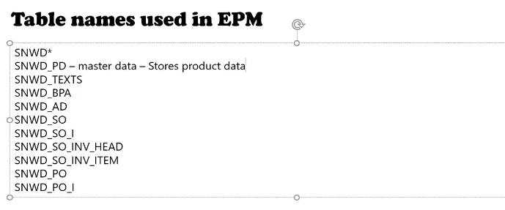

**SNWD_PD:**

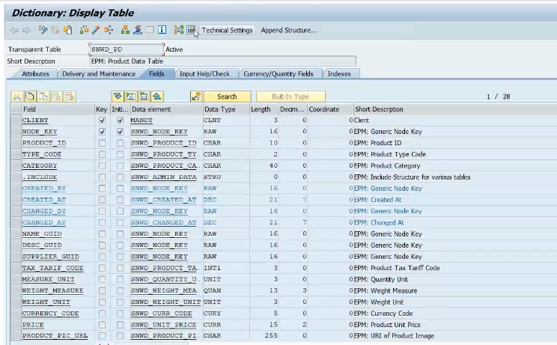

**Primary KEY: NODE_KEY**

**GUID based table designed why it is ?**

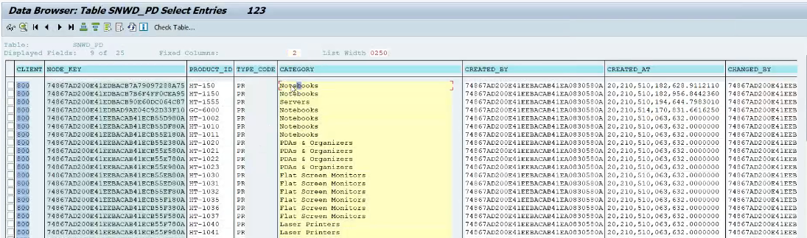

**SNWD_TEXTS: description of the product for language specific**

* Copy the snwd_pd- desc_guid and paste it into the SNWD_TEXTS- parentkey

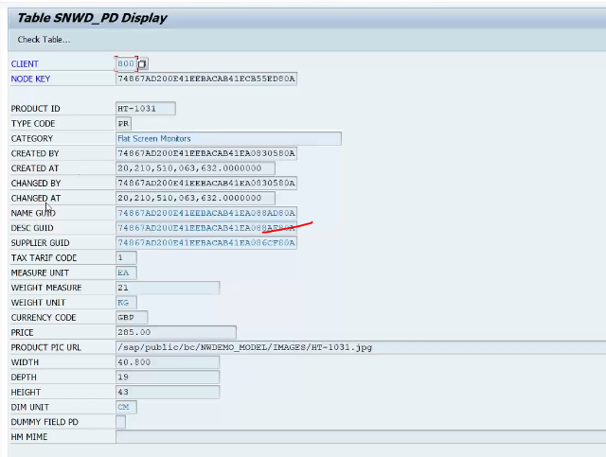

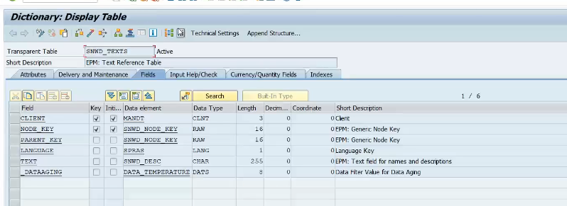

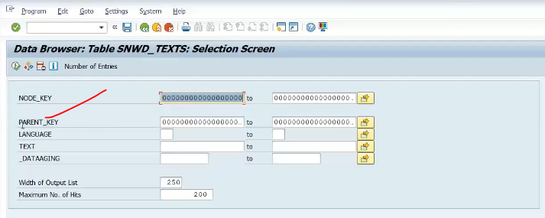

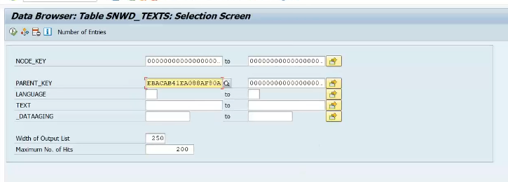

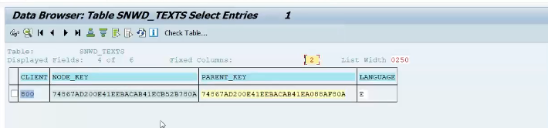

**DBL click it**

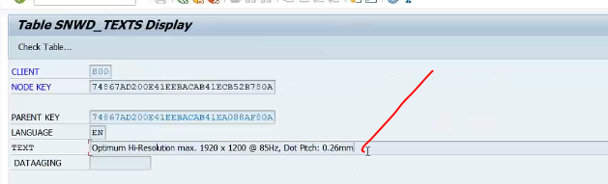

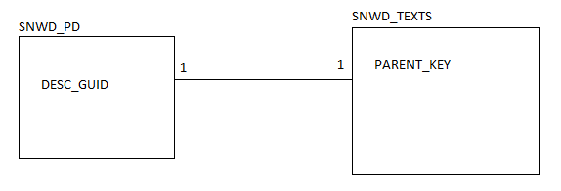

[**https://www.tcodesearch.com/sap-tables/search?q=snwd**](https://www.tcodesearch.com/sap-tables/search?q=snwd)

**Genetrate the EPM model table data: TCODE: SEPM_DG**

**SNWD_BPA:**

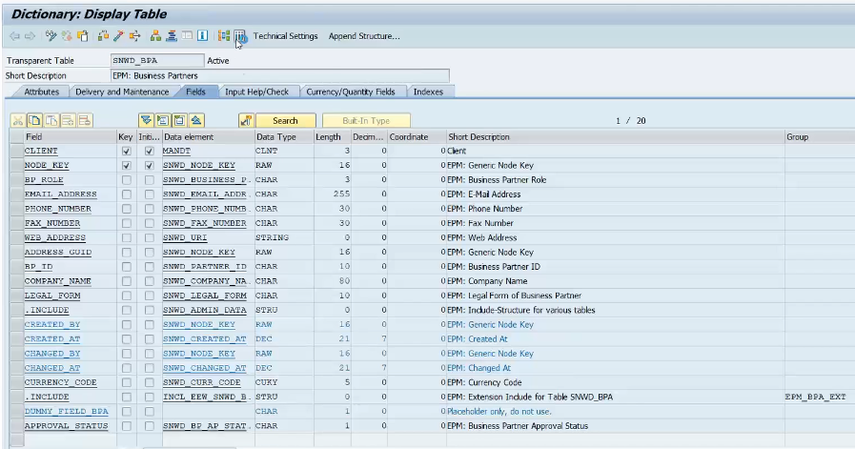

**Copy the data supplier_guid from SNWD_PD**

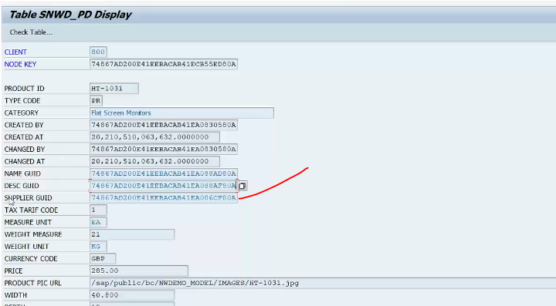

**Copy this SNWD_PD-supplier_guid and paste it in SNWD_BPA-NODE_KEY**

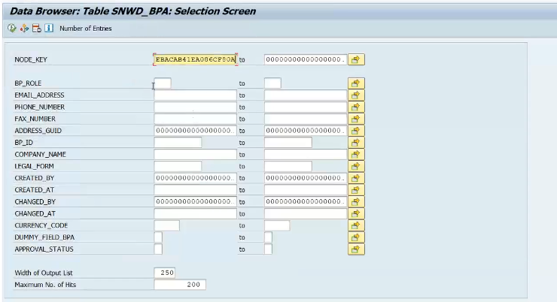

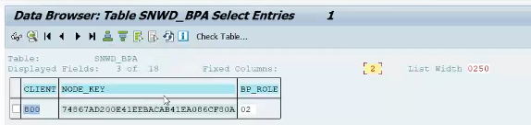

**Dbl click it**

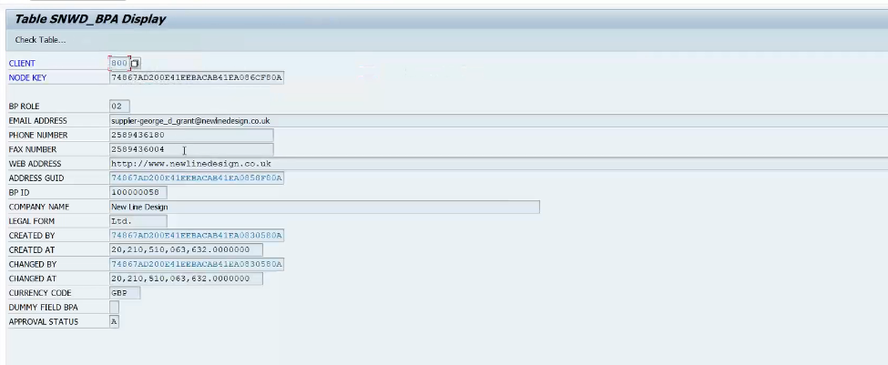

**SNWD_BPA = contains both the supplier and customers data**

**BP_ROLE- tell us what type of data it is.**

**02- is the supplier**

1. **Customer**

**SNWD_SO:**

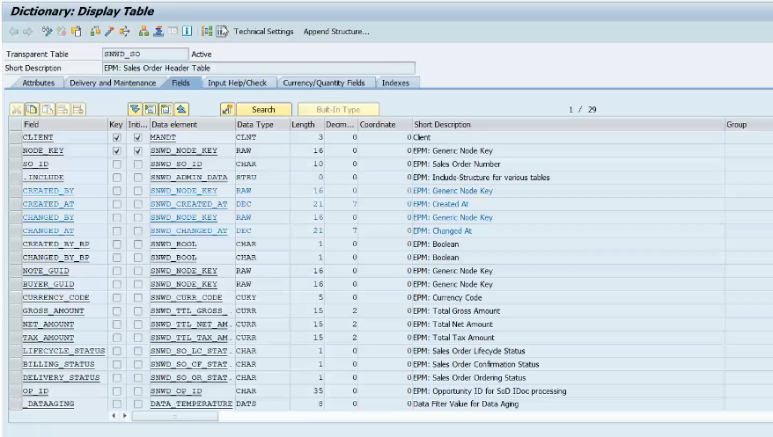

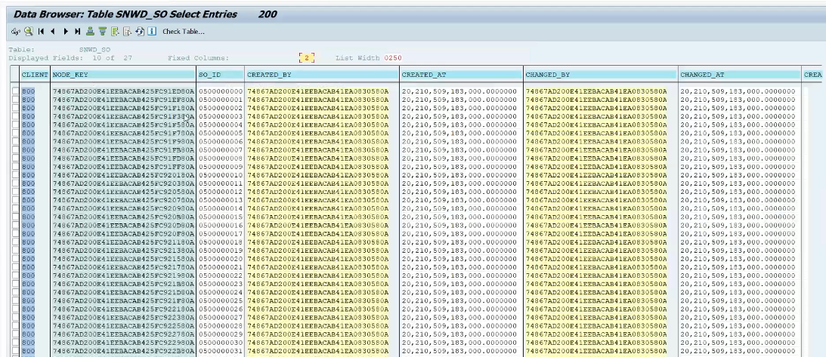

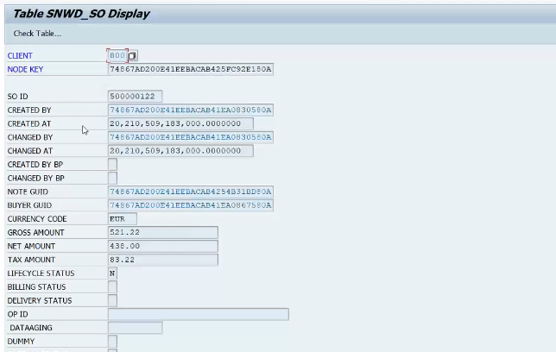

**I want to know the this so created for which customer.**

**Based on SNWD_SO-BUYER_GUID**

**Copy this buyer_guid**

**Go to SNWD_BPA-NODE_KEY**

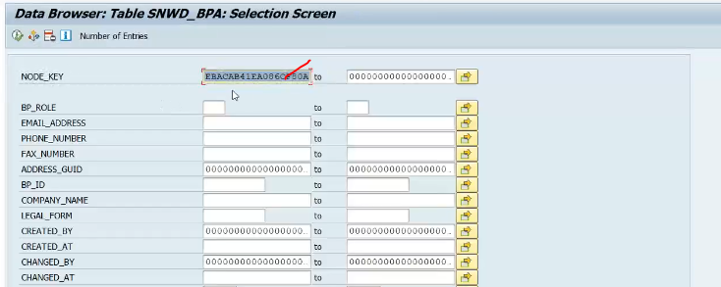

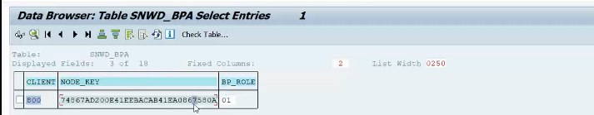

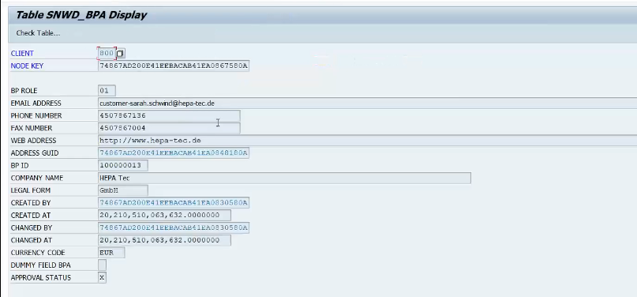

**What is the sales order items for sales order header**

**SNWD_SO 🡪 SO Header**

**SNWD_SO_I 🡪SO Items**

**Link between two tables is SNWD_SO-NODE_KEY 🡨🡪 SNWD_SO_I-PARENT_KEY**

**Copy the SNWD_SO-NODE_KEY 🡨🡪 SNWD_SO_I-PARENT_KEY**

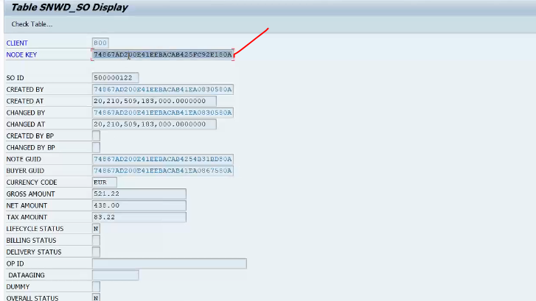

**And paste it into the SNWD_SO_I-PARENT_KEY**

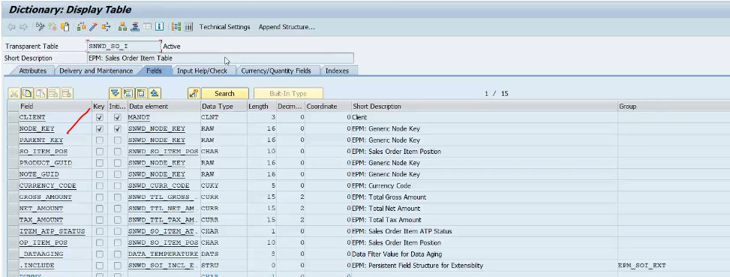

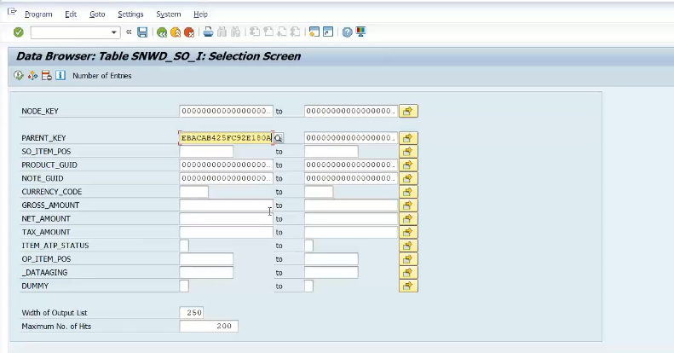

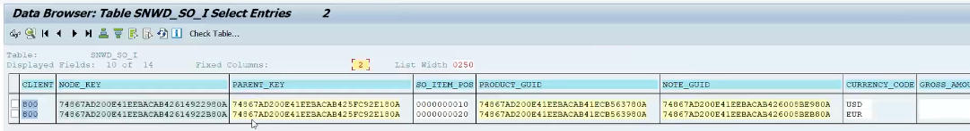

**SNWD_SO_I-PRODUCT_GUID 🡨🡪 SNWD_PD-PARENT_KEY (Link between the product GUID and Product table )**

**Copy this PRODUCT_GUID**

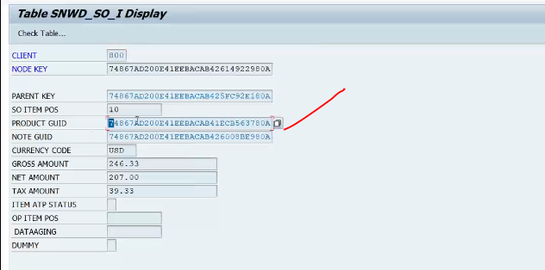

**And paste it into the SNWD_PD-PARENT_KEY**

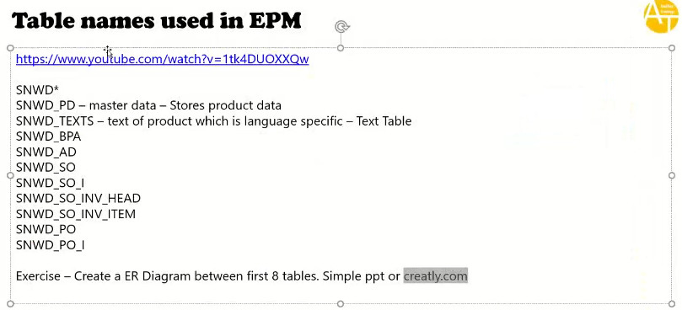

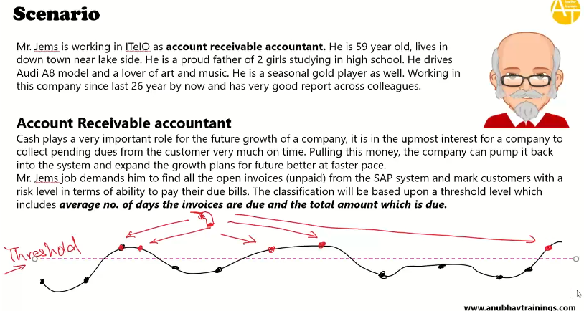

**Red colors are customer defaulters whose not paid the loans, threshold limit is dynamical changing**

**Agile Methodology:**

* **Gives planning to complete the task**
* **Every company operates mode of SPRINT**
* **They follow the agile methodology and they follow the scrum principles to do the development**
* **In part of AGILE methodology entire team is called as SCRUM team, their will be a scrum lead and all the development happens inform of SPRINTS, each sprint typically between 2 to 4 weeks and at the end of every sprint you should have a usable piece of software with the quality introduced in the system.**

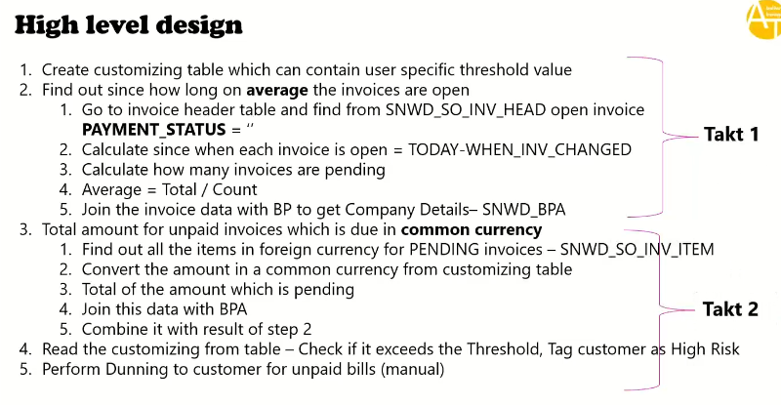

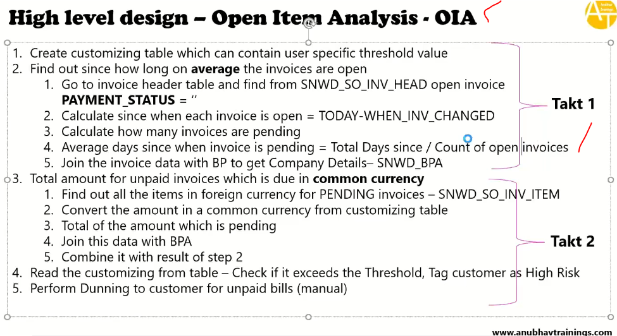

**OIA 🡪 means which are unpaid by customers**

**Annexure:**

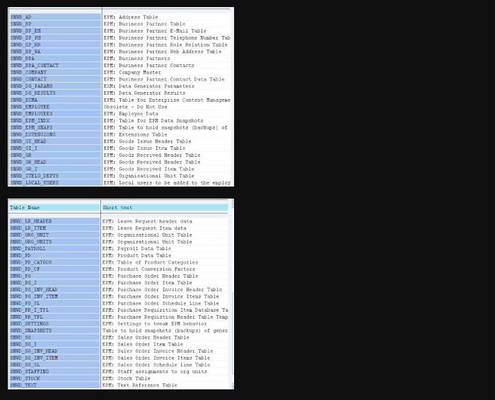

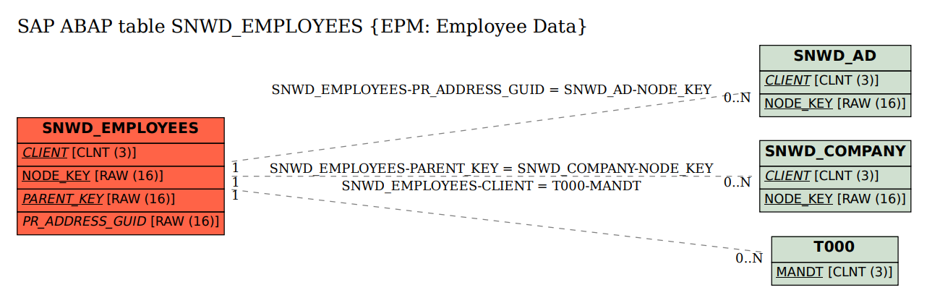

[**https://www.tcodesearch.com/sap-tables**](https://www.tcodesearch.com/sap-tables)

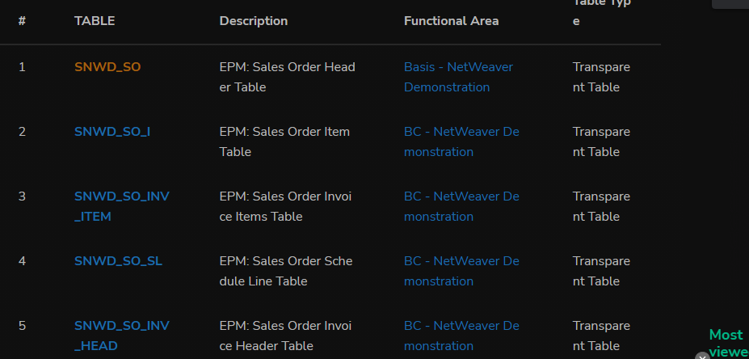

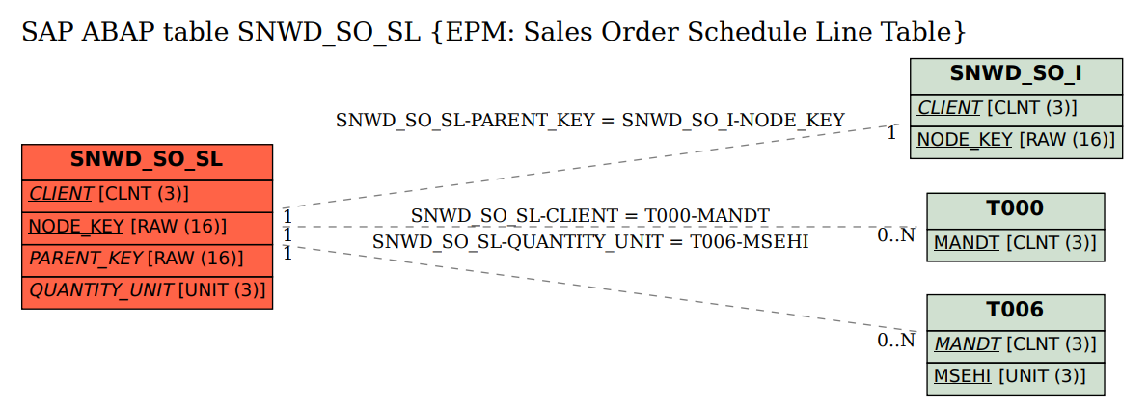

**Foreign kEy relations:**

[**https://www.sapdatasheet.org/abap/tabl/snwd_bpa.html**](https://www.sapdatasheet.org/abap/tabl/snwd_bpa.html)